Software engineering for big data analaysis

CSA-1035

EXP NO:- 22

Using Raptor- Draw and validate the flowchart to calculate Factorial of a number. Factorial of a positive integer (number) is the sum of multiplication of all the integers smaller than that positive integer. For example, factorial of 5 is 5 \* 4 \* 3 \* 2 \* 1 which equals 120.

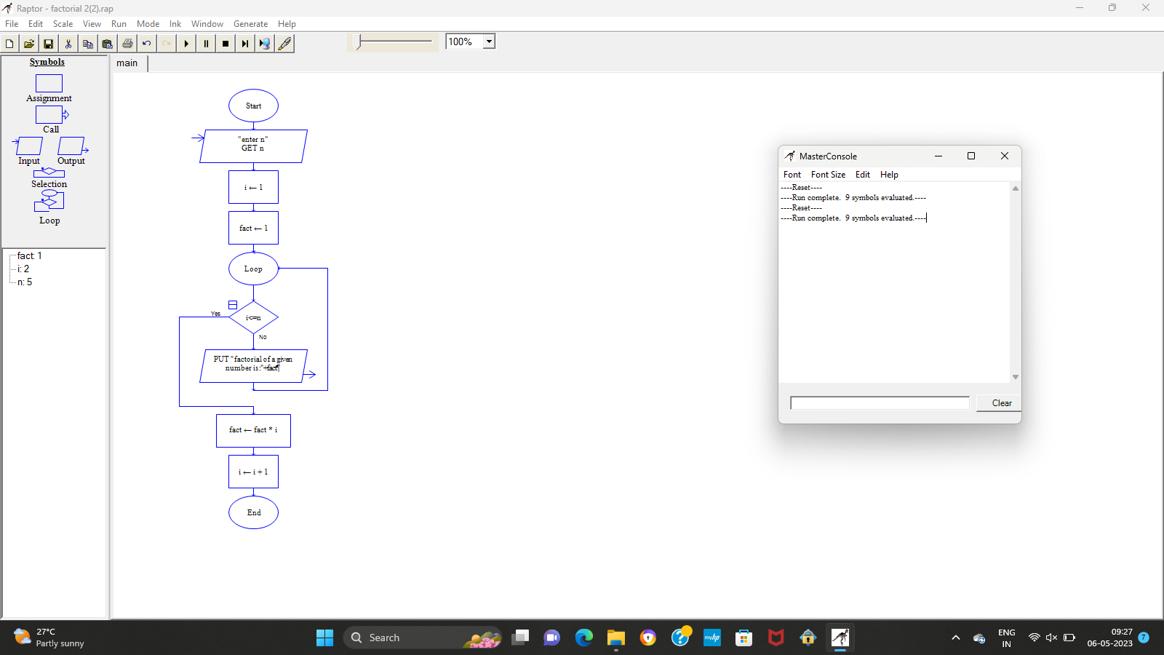

RESULT:-

BY Using Raptor for the givenumber fctorial is verified successfully